Factorial!
Platform: HackerEarth
Language: C
Module 5, Question 3

Problem Link
https://www.hackerearth.com/practice/basic-programming/input-output/basics-of-input-output/practice-problems/algorithm/find-factorial/

Problem Statement
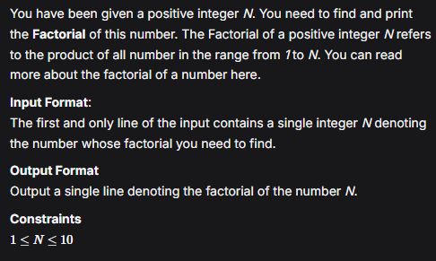

C Code
#include <stdio.h>

int main() {
int n;
scanf("%d", &n);

unsigned long long fact = 1;
for (int i = 2; i <= n; i++)
fact *= i;

printf("%llu\n", fact);
return 0;
}

Screenshot of Successful Submission



